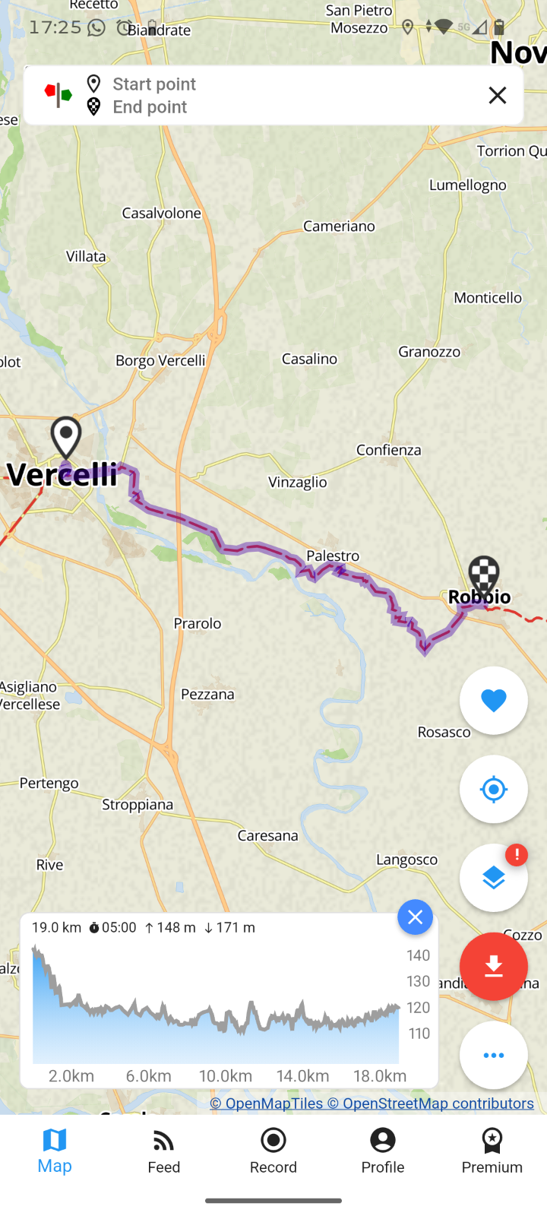
15. Vercelli – Robbio
15th^{th} June

Accommodation
Maybe a hostel? Might need to adjust – awaiting response to email enquiry

